初中英语圣诞节作文200字

The Christmas season is a time of joy and excitement for many people around the world. It is a time to celebrate the birth of Jesus Christ and to spend time with family and friends.

One of the most popular traditions during Christmas is the exchange of gifts. People often buy presents for their loved ones and wrap them up in beautiful wrapping paper. Some people also like to make their own gifts, such as knitted scarves or homemade cookies.

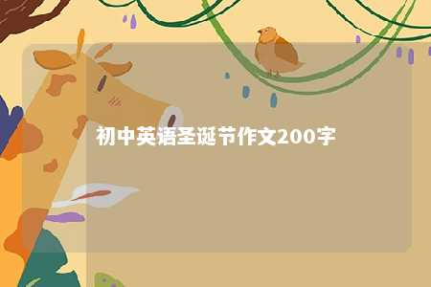

Another tradition is the decorating of Christmas trees. People often put up trees in their homes and decorate them with lights, ornaments, and garland. Some people also like to put up other decorations, such as Santa Claus figures and reindeer.

One of the most famous Christmas songs is "All I Want for Christmas Is You" by Mariah Carey. The song has become a classic and is played on radio stations and in stores during the holiday season.

Overall, Christmas is a time of joy and celebration for many people. It is a time to spend with family and friends and to appreciate the love and support that they provide.

文章地址：<https://www.yyzq.team/post/359409.html>